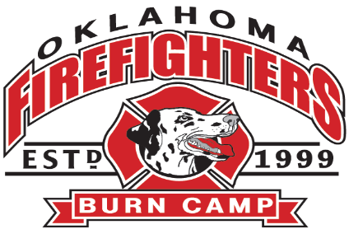
- Young Adult Retreat

Mission - OKFFBC young adult retreat is open to all young adults from our burn camp community, ages 16-25. This retreat is designed to help create a support network with people who face similar challenges in their lives, practice leadership skills that will help foster better life choices, and build healthy lifestyle skills to support a healthy body and mind.
- Sessions may range from teaching life skills like basic auto maintenance, cooking, finance/budgeting, and interview etiquette, to fun activities like camp counselor training and bonding activities.

- Attendees are expected to come to the retreat with a positive attitude, an open mind, and be prepared to learn basic life skills that are the building blocks to help each person be more successful, productive, efficient, and financially stable in their daily lives

- The retreat also includes time to socialize and bond with other burn camp family members, providing the opportunity to get to know each other in a much smaller setting than found at Burn Camp.

- Attendees must be a camper, former camper, counselor, or volunteer who has participated in OKFFBC in previous years. The age range is 16-25, however, exceptions can be made at the discretion of the OKFFBC executive board.

